Writing Samples for Elizabeth Ilawan

Makapu‘u Point Trail and Tidepools
The very first hike I did while visiting Oahu to scope out living and job prospects is the Makapu‘u Point trail. Located about ten minutes away from the Halona Blowhole, off of the Kalanianaole Highway (Hwy. 72). This is a relatively easy hike that is completely paved and gradually winds upwards towards some of the most impressive views of the makai (ocean-side) and mauka (mountain-side) of the island. The total hike is about two miles round-trip and I've seen people ride mountain bikes there, take strollers for their kids, and walk their dogs. From about November to February, Makapu‘u Point is a great place to do some whale watching. About 3/4th of the way up there is a level part with a big informational sign explaining which whales show up around the island.
Interestingly enough Makapu‘u Point has become the "happening place" to be for the first sunrise of the new year. The locals have adopted the Japanese tradition of watching the first sunrise and this place definitely doesn't disappoint. I along with hundreds of others hiked up the trail in the dark and eagerly looked for a comfy spot among the rocky crevices to enjoy the new dawn. As we sat and watched the first few rays peek up above the horizon, Taiko drummers welcomed the New Year and men dressed in traditional Hawaiian garb blew conch shells.
Continuing all the way up the slopes of the mountain, one sees all types of vegetation, mainly desert cacti. At the summit of the trail, there is access to some pillboxes, which can be a completely different hike if you wanted something more demanding. There is a lighthouse right at the bottom of the summit with a beautiful backdrop of the ocean. There, up high, one can also see Rabbit Island in the not-too-far distance and Makapu‘u Beach. On any given day one can see people paragliding onto the shores below.
Makapu‘u Point trail isn't the only one that starts at the trailhead near the parking lot. There is an unpaved trail that leads to a small little rocky beach called Allen Davis (why it's called that, I don't know). The trail to the beach is really short and is probably just over a mile round-trip. People often climb the huge rocks to gain access to the wooden pole, which acts as a launch pad for those brave adventure-seekers that want to jump in the water. I still haven't tried this yet, but one day soon I will.
There is another adventure that also awaits would be fun-seekers here. Behind the sign I mentioned earlier about the whales is a rocky and fairly steep "trail" that leads to the tide pools below. When I first arrived on the island and watched people make this trek, I thought they were crazy, but three months later I was making my way down the slippery rocks myself. I finally convinced a friend of mine to do it with me (in case I slide off the side of the mountain). It takes about thirty minutes to hike down and if you're short like me, you'll be climbing rocks down and back up again. Climbing down is the scary part because that's when sliding forward and off the side of the mountain is more likely. Luckily we both kept pretty good footing all the way down and back up. The tide pools are a marvel all their own. They shimmer with emerald green water and are very inviting after a rough descent.
For those of you willing to hike down to these pools, I would caution you to bring reef-walker or aqua-socks, so that you don't slip on the wet stones inside the pools. I found it very difficult to maneuver while swimming in them. I also caution you to never turn your back to the ocean. We went on a day where the waves were very high and the surf was pretty violent. At any given moment a huge wave can crash over the pools and throw you out of one of them. A friend of mine told me the story of that exact thing happening to him once. Needless to say I stayed in the pool closest to the mountain.
Whether you just want to enjoy the easy hike to the summit or venture out to the tide pools, I hope you get to enjoy Makapu‘u Point on a visit here. It's a very tranquil place and offers some of the best views of the island.
Malasadas vs. Beignets
Today's post is dedicated to all things doughy, sweet and fried! Here in Honolulu, Leonard's Bakery is known for its malasadas, which are round tennis ball sized pieces of yeast dough that are deep fried and covered in granulated sugar. These confections were brought over to Hawai‘i for the celebration of Fat Tuesday by the resident Catholic Portuguese (mostly from Madeira and the Azores). The tradition would be to use up all the stored sugar and butter before the start of Lent by having a celebration and frying up malasadas.
Since its founding in 1952, Leonard's popularity, or rather the popularity of the malasada in general has steady increased, bringing locals and tourists alike to this small, retro-looking little bakery on Kapahulu Avenue. At almost any given time of day or night one can see a line of hungry customers waiting for their chance to indulge in the warm pillowy pastries.
Having grown up in New Orleans and having eaten beignets throughout my childhood, I have developed a huge crush on these sweet treats. (Though I try to only have them on ocassion.) Similiar to the malasada, a beignet is the French version of a yeast dough, deep fried fluffy confection. These however, are square-shaped and covered in powdered sugar. Traditionally neither the malasada nor the beignet were filled, but Leonard's has taken to filling theirs with flavored custards (lilikoi, guava, pineapple, and chocolate).
Since I'm on the subject of the delectable yeast dough pastries, I feel that I must include the New Orleanian version of a Fat Tuesday or Mardi Gras treat. Growing up every child in New Orleans get exposed to King cakes, either at home or in elementary school. On Friday afternoons a few weeks before Mardi Gras, our class had a King cake party, and we would impatiently wait for our teacher to slice up the huge King cake that a loving parent brought to the class. In addition to the longing to taste this cinnamon-sugary cake (more like a Danish pastry dough), we all hoped that our particular section of the King cake contained the hidden treasure of a naked little plastic baby. This plastic baby is supposed to represent baby Jesus and it's thought to be good luck if you get the piece with this little guy inside. As a kid I was lucky to have a few little plastic babies, but be careful and make sure to inspect your piece carefully if you ever get to try this.
Kūkaniloko Birth Site
Nestled away in a field right off of bustling Route 80, the Kūkaniloko Birth Site is an odd mix of ancient Hawaiian mana (power or energy) and tranquility. Cradled by the majestic Waimea mountain range in the far distance and surrounded by pineapple plantations, this sacred site was once the place where all the royalty and Ali'i came to give birth. The ceremonies surrounding the births conducted here are still unclear to me, but at present day it's a place of stillness and quiet reflection. Pilgrims come to the site to ask for blessings not only for childbirth, but also for new beginnings and endeavors. Some, like myself, bring offerings of fresh flowers leis, which are carefully placed on the scattered stones that comprise the main ritual area.
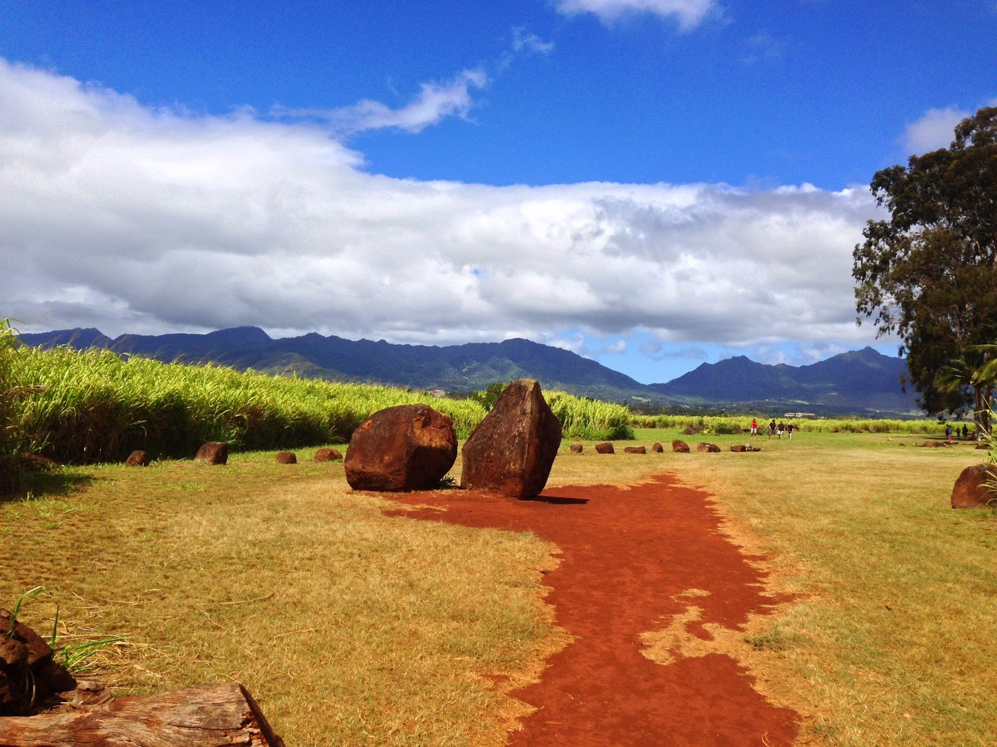
Entrance to the site.

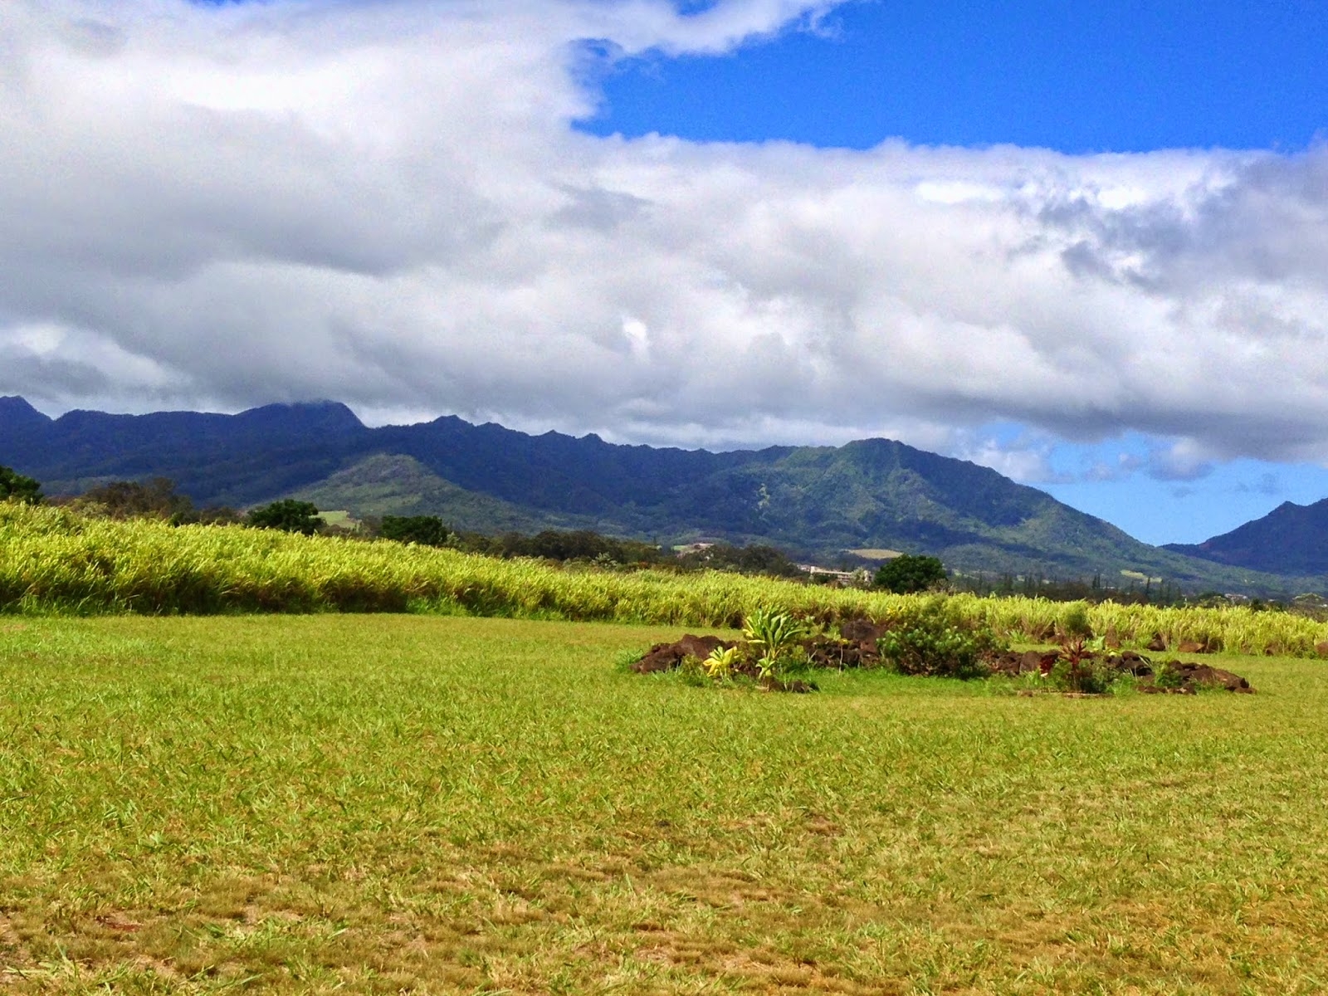
Waimea Mountains in Background
The stones themselves are large lava boulders, ranging in size, shape and height. There is a main birthing stone, but I couldn't detect it just by looking at them. There are other stones surrounding the field. Each one reminding me of a guardian or sentinel, protecting the sacredness within its boundaries. Many have markings on them and are believed to have been used to calculate celestial bodies. Could the ancient Hawaiians have used them as a sort of calendar like the Mayans?
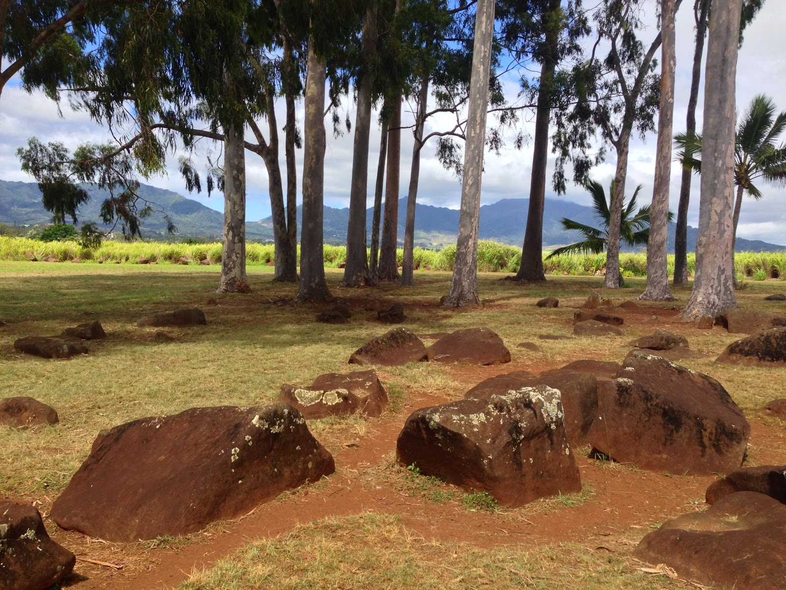
Center of birthing stones

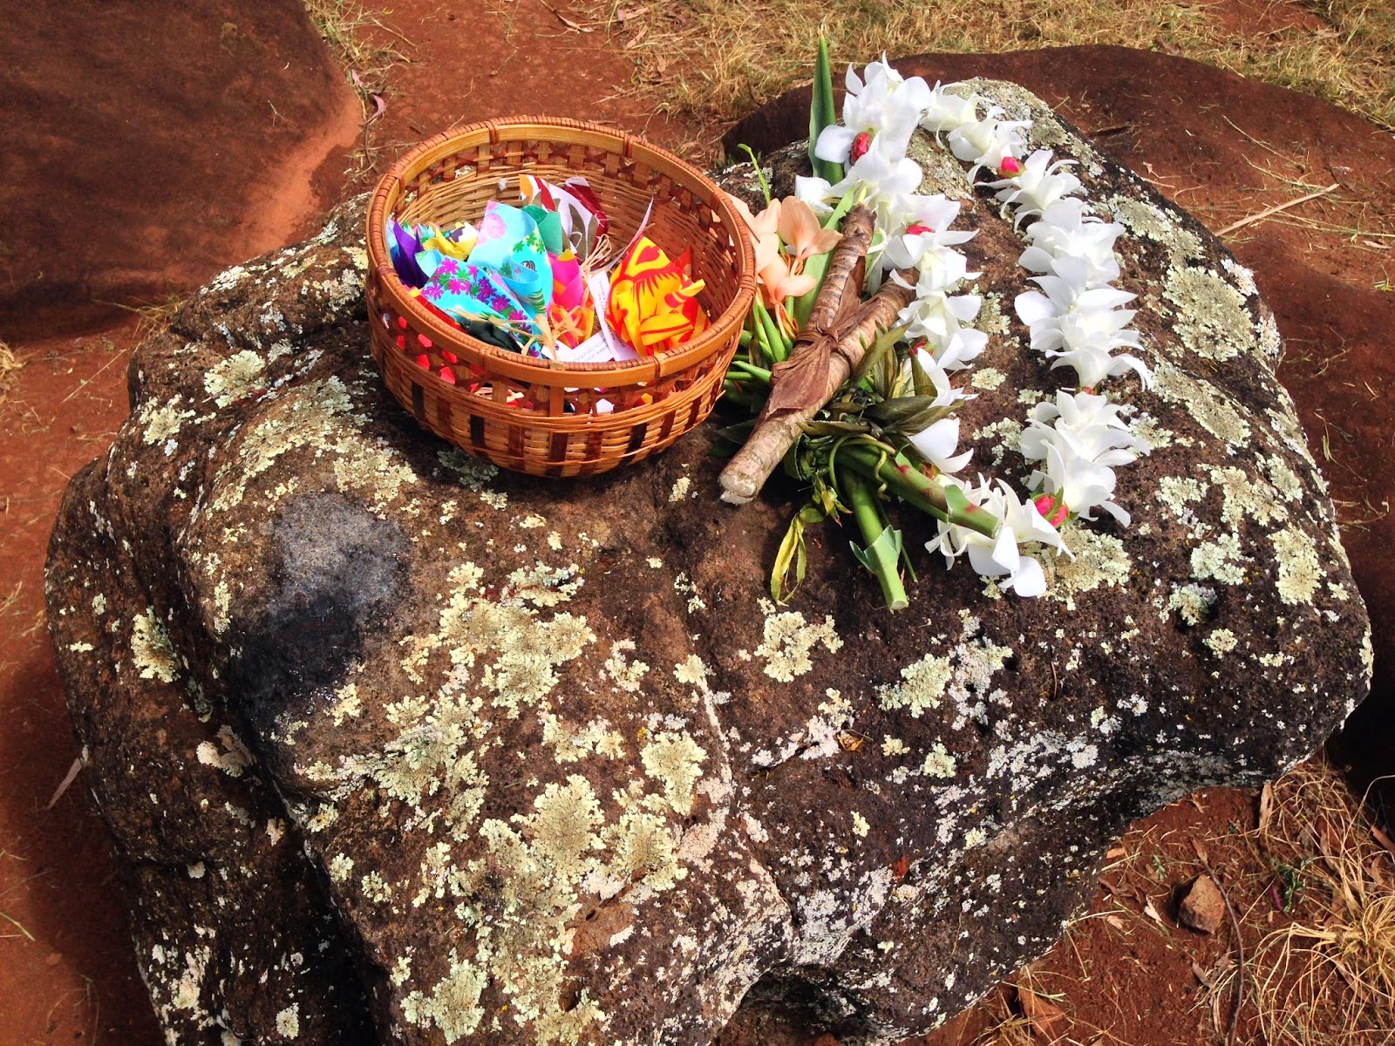
Offerings left by visitors
As I take leave of this sacred place, I walk the short red dirt road path back to the car feeling that somehow the spirits there did indeed hear my prayers and whispered their blessings to me in the gentle breeze. Turning back to the site, now in the distance, I give thanks to the Universe. I hope you all get an opportunity to visit the site if you're ever on the island.
